**Lesson 11 Demo 1**

**Creating a Virtual Machine** 

Steps to be followed:

1. Creating a Virtual Machine

**Step 1: Creating a Virtual Machine**

1.1 Log in to the Azure portal at <https://portal.azure.com>

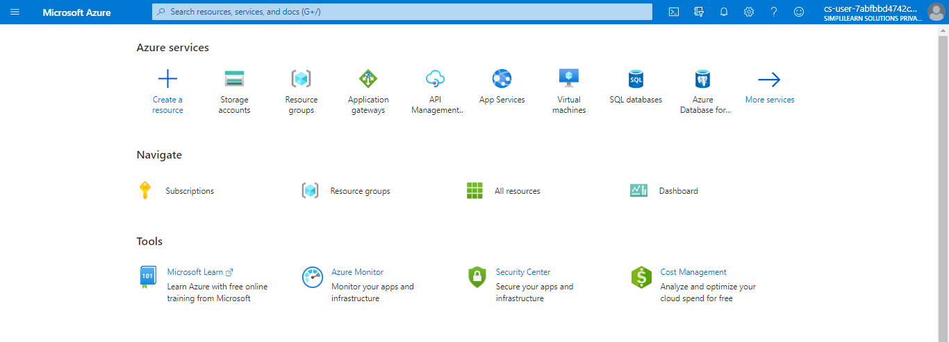

1.2 Type **virtual machines** in the search box

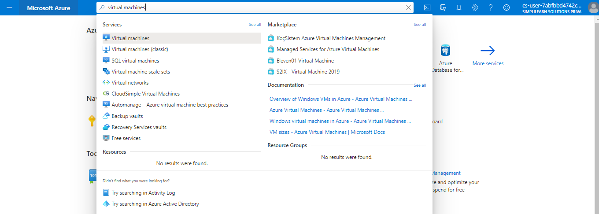

1.3 Under **Services**, select **Virtual machines**

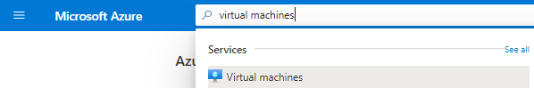

1.4 Click on **Add > Virtual machine**

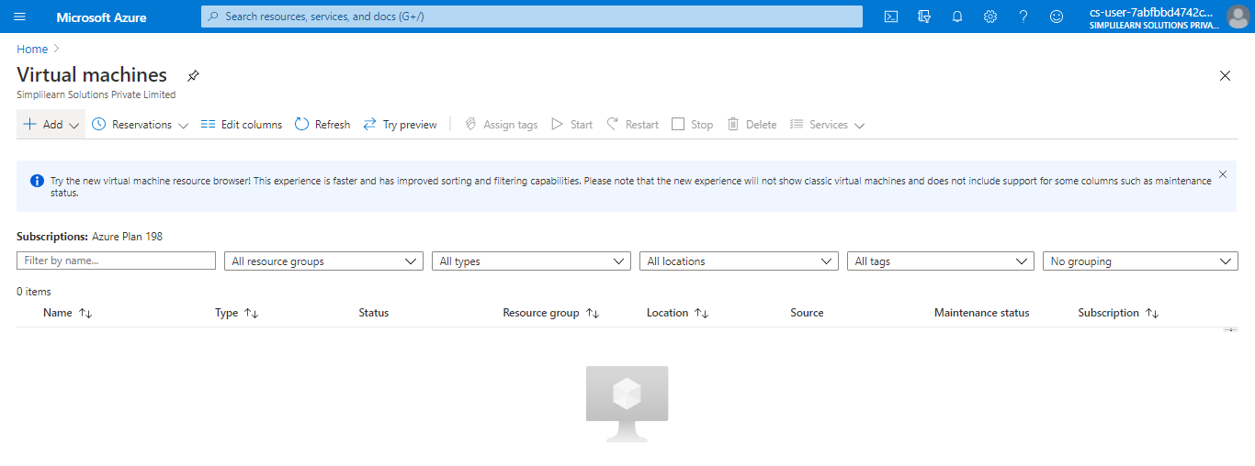

1.5 In the **Basics** tab, under **Project details**, make sure the correct subscription is selected and then choose a resource group or click on **Create new** to create a new resource group

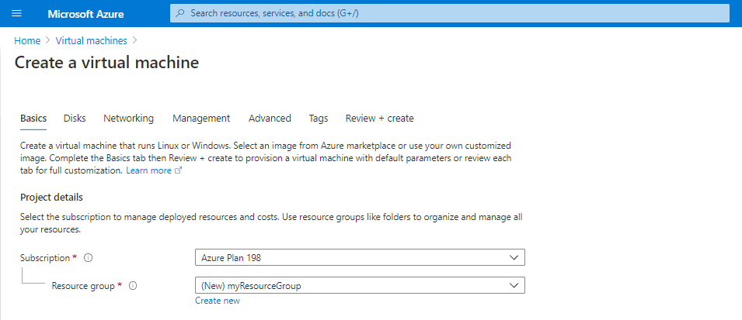

1.6 Under **Instance details**, type a name for the virtual machine, choose your **Region**, and then choose the image. Leave the others as default

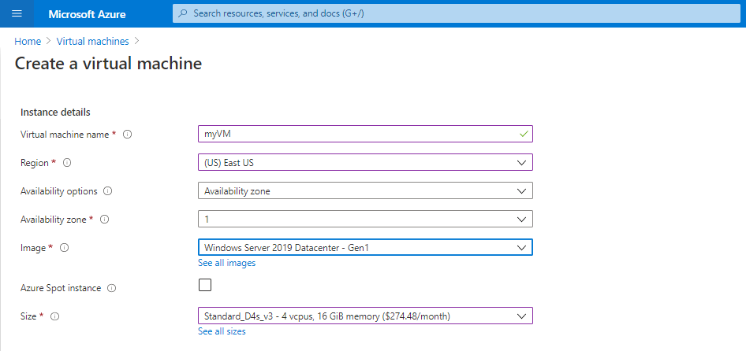

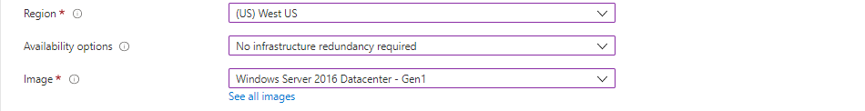

1.7 Under **Administrator account**, provide a username and password

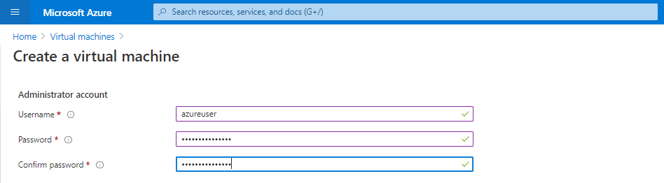

1.8 Under **Inbound port rules**, choose **Allow selected ports**

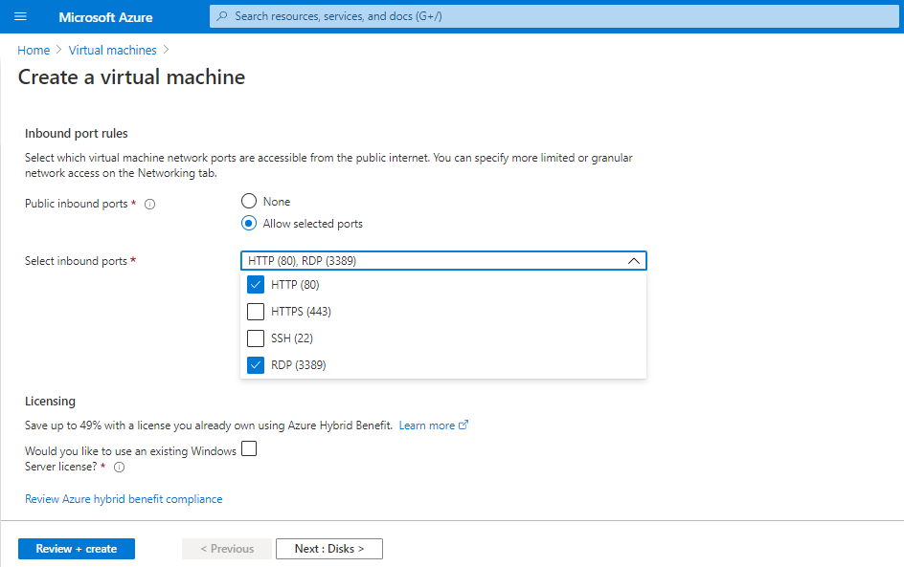

1.9 Leave the remaining as default

1.10 Click on **Review + create**

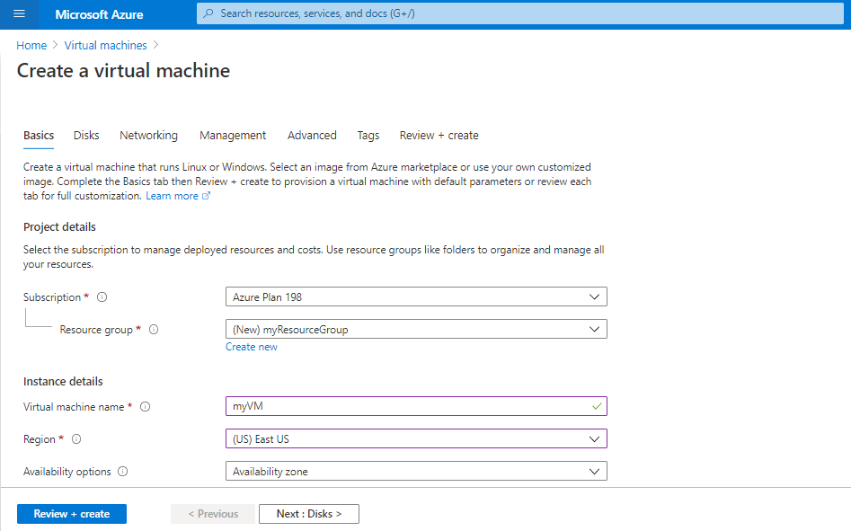



1.11 After the validation passes, click on **Create**

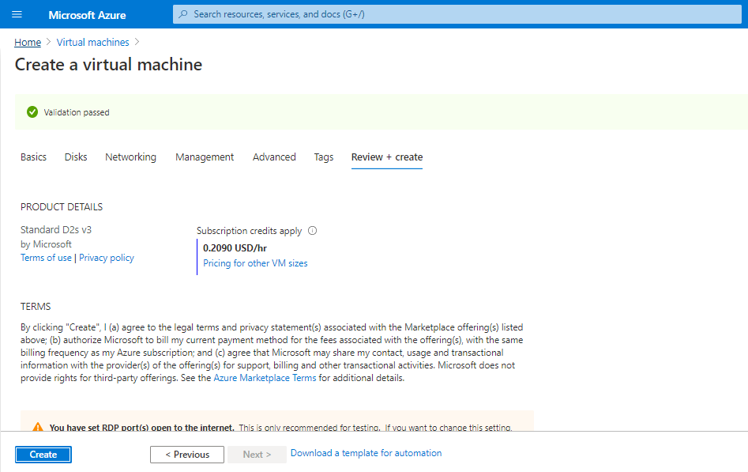

Your Virtual Machine will get deployed.

